**San Francisco Bay University**

**EE553 - System on Chip (SoC) Design**

**Homework Assignment #3**

**Due day: 3/9/2022**

**Instruction:**

1. **Push the answer sheet to Github**
2. **Overdue homework submission could not be accepted.**
3. **Takes academic honesty and integrity seriously (Zero Tolerance of Cheating & Plagiarism)**
4. Complete SoC design to blink one LED and shift back and forth among 4 LEDs on Zybo Z7-10 board

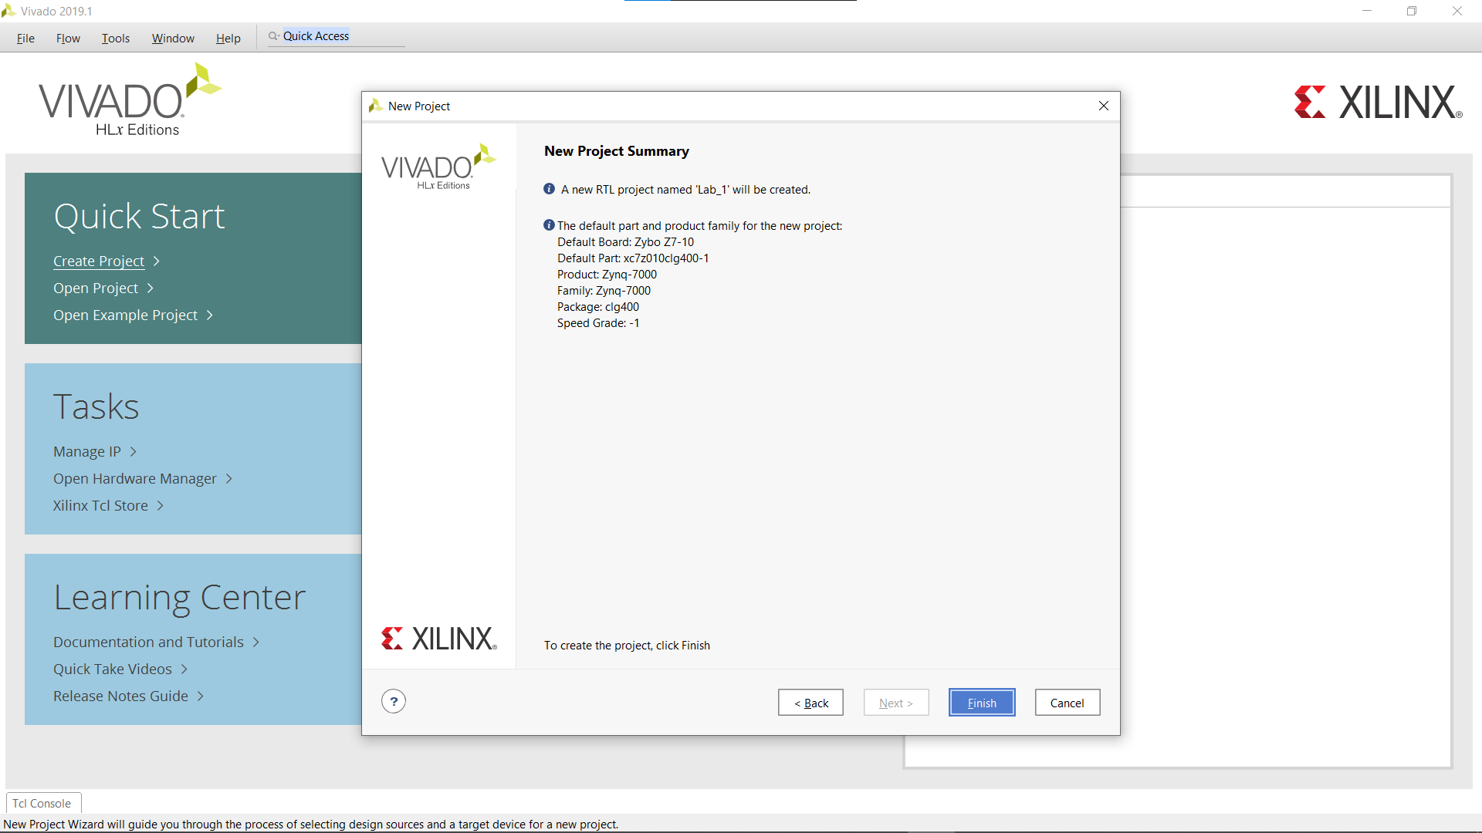

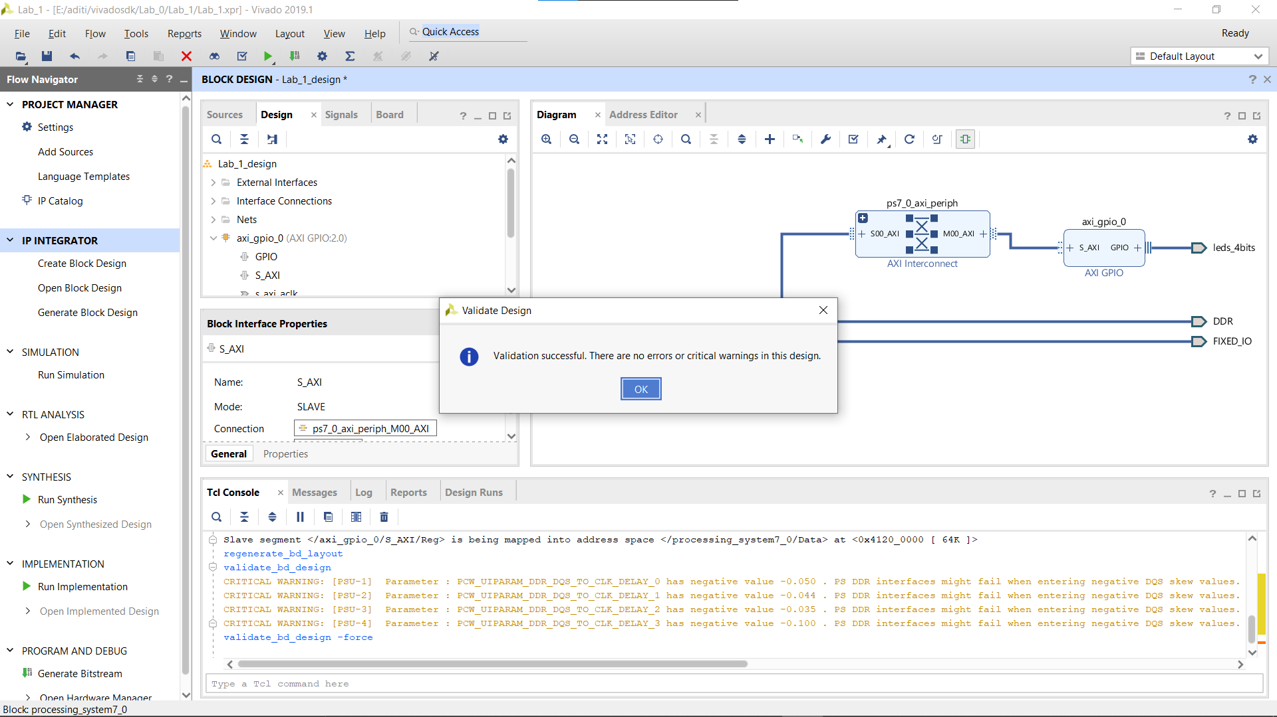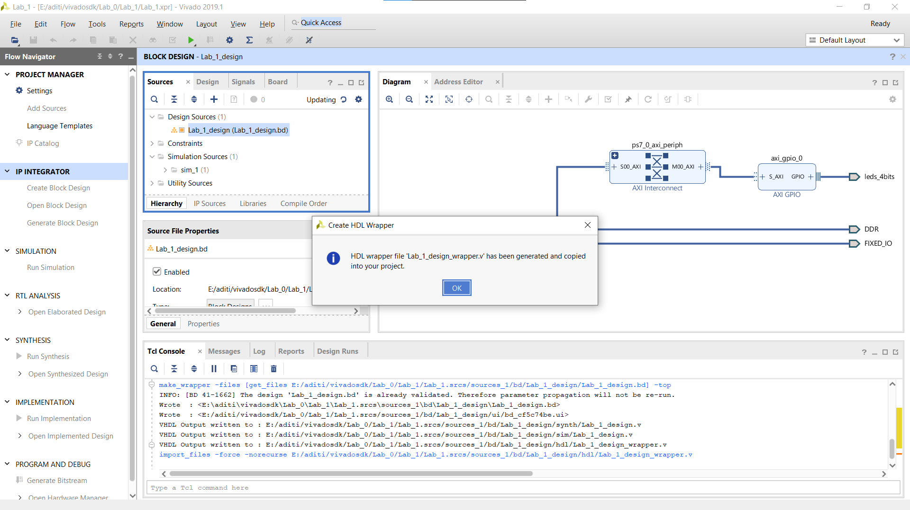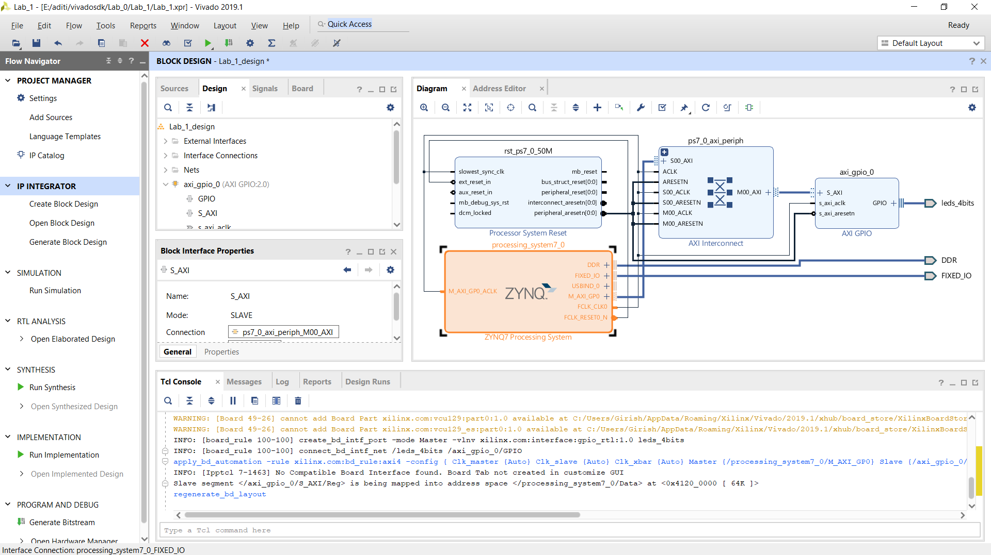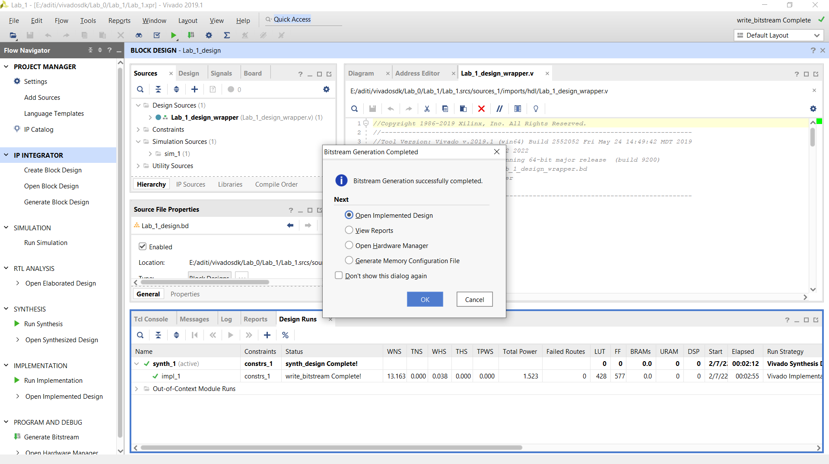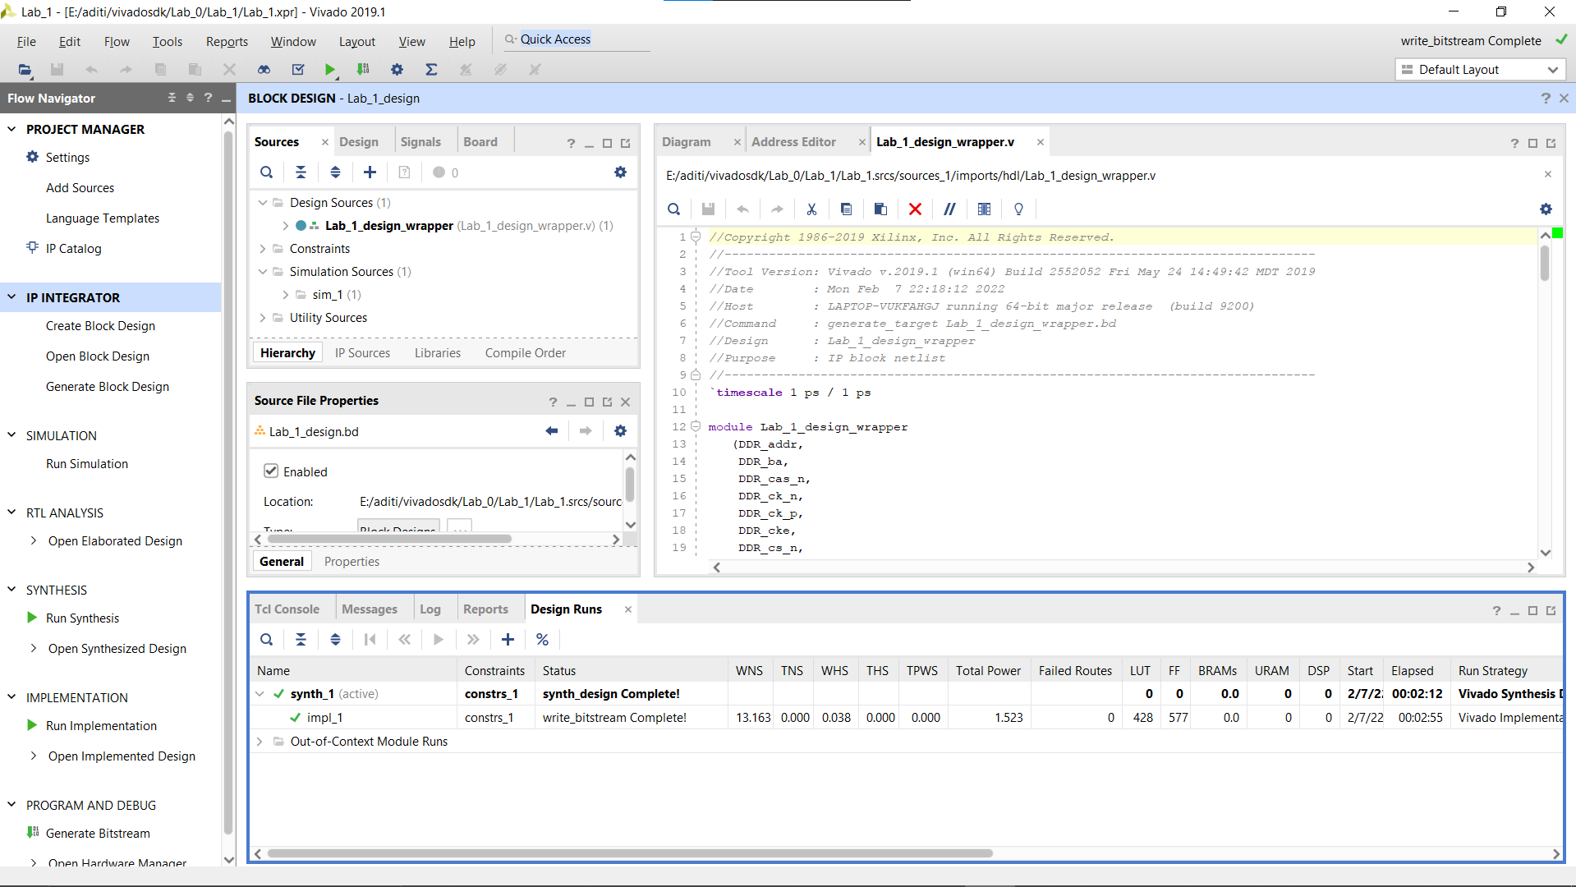

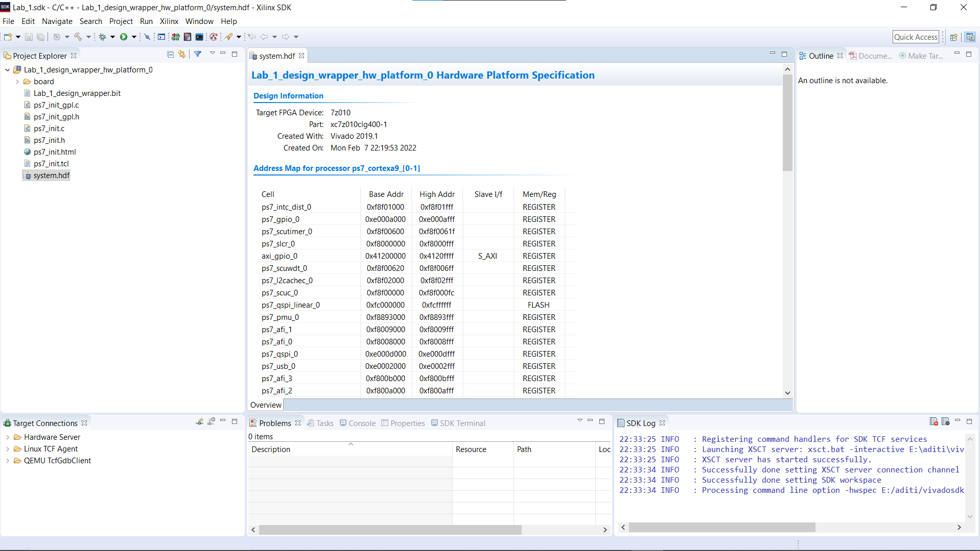

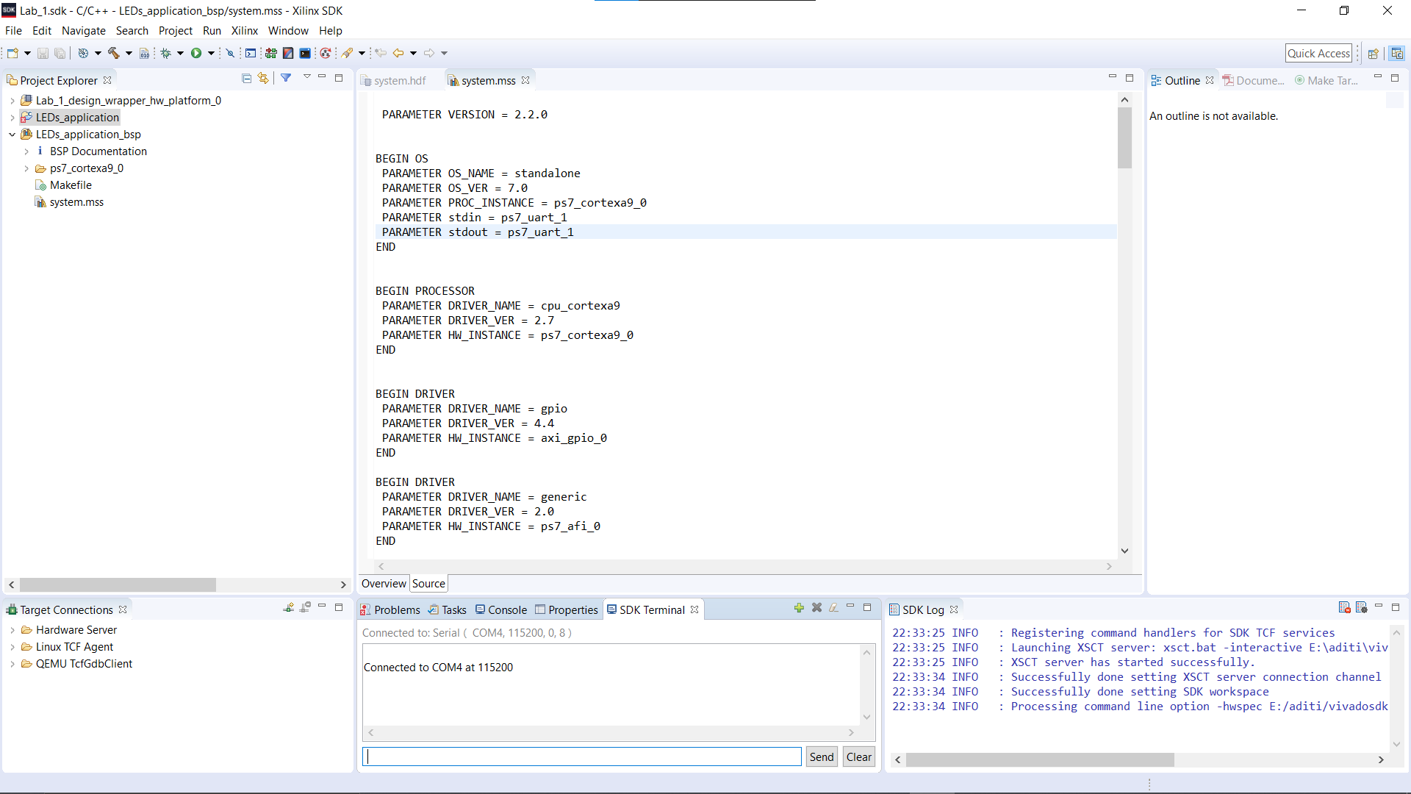

CODE-

#include "xparameters.h"

#include "xgpio.h"

#include "xstatus.h"

#include "xil_printf.h"

/* Definitions */

#define GPIO_DEVICE_ID XPAR_AXI_GPIO_0_DEVICE_ID

#define LED 0x9

#define LED_DELAY 10000000

#define LED_CHANNEL 1

#define printf xil_printf

XGpio Gpio;

int LEDOutputExample(void)

{

volatile int Delay;

int Status;

int led = LED; /* Hold current LED value. Initialise to LED definition */

/* GPIO driver initialisation */

Status = XGpio_Initialize(&Gpio, GPIO_DEVICE_ID);

if (Status != XST_SUCCESS) {

return XST_FAILURE;

}

/*Set the direction for the LEDs to output. */

XGpio_SetDataDirection(&Gpio, LED_CHANNEL, 0x0);

/* Loop forever blinking the LED. */

while (1) {

/* Write output to the LEDs. */

XGpio_DiscreteWrite(&Gpio, LED_CHANNEL, led);

/* Flip LEDs. */

led = ~led;

/* Wait a small amount of time so that the LED blinking is visible. */

for (Delay = 0; Delay < LED_DELAY; Delay++);

}

return XST_SUCCESS;

}

/* Main function. */

int main(void){

int Status;

/* Execute the LED output. */

Status = LEDOutputExample();

if (Status != XST_SUCCESS) {

xil_printf("GPIO output to the LEDs failed!\r\n");

}

return 0;

}

/* Include Files */

#include "xparameters.h"

#include "xgpio.h"

#include "xstatus.h"

#include "xil_printf.h"

/* Definitions */

#define GPIO_DEVICE_ID XPAR_AXI_GPIO_0_DEVICE_ID /* GPIO device that LEDs are connected to */

#define LED 0x1 /* Initial LED value - X00X */

#define LED1 0x8

#define LED_DELAY 100000000 /* Software delay length */

#define LED_CHANNEL 1 /* GPIO port for LEDs */

#define printf xil_printf /* smaller, optimised printf */

XGpio Gpio; /* GPIO Device driver instance */

int LEDOutputExample(void)

{

volatile int Delay;

int Status;

int led = LED; /* Hold current LED value. Initialise to LED definition */

int led1=LED1;

/* GPIO driver initialisation */

Status = XGpio_Initialize(&Gpio, GPIO_DEVICE_ID);

if (Status != XST_SUCCESS) {

return XST_FAILURE;

}

/*Set the direction for the LEDs to output. */

XGpio_SetDataDirection(&Gpio, LED_CHANNEL, 0x0);

/* Loop forever blinking the LED. */

while (1) {

/* Write output to the LEDs. */

XGpio_DiscreteWrite(&Gpio, LED_CHANNEL, led);

XGpio_DiscreteWrite(&Gpio, LED_CHANNEL, led1);

led = led<<0x1;

led1 = led1>>0x1;

for (Delay = 0; Delay < LED_DELAY; Delay++);

}

return XST_SUCCESS; /* Should be unreachable */

}

/* Main function. */

int main(void){

int Status;

/* Execute the LED output. */

Status = LEDOutputExample();

if (Status != XST_SUCCESS) {

xil_printf("GPIO output to the LEDs failed!\r\n");

}

return 0;

}

1. Design hardware and software to make 2 LEDs at the two ends of 4 LEDs on the board blinking and move in different directions, and then back and forth

